LAB #03
LOOPING CONSTRUCTS

Submitted to
Rohail Shaikh

Submitted by
Bheesham Kumar Sajnani
(25F-DS-020)

Program 01:
CODE:
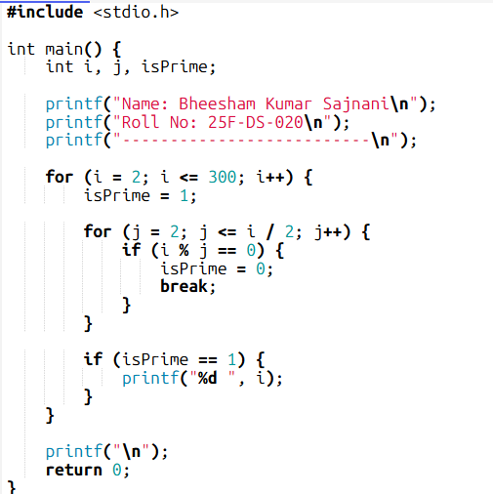
OUTPUT:
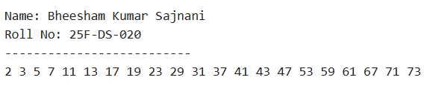
Program 02:
CODE:
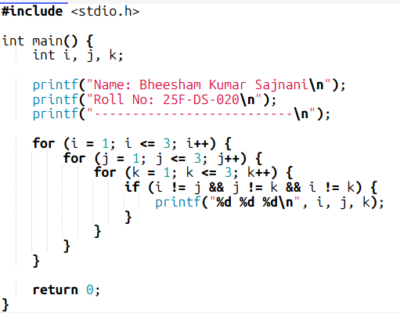
OUTPUT:
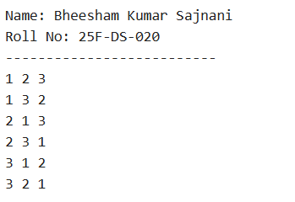

Program 03:
CODE:
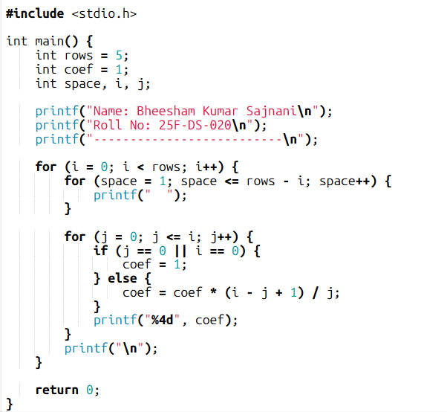
OUTPUT:
